MEMO

To: Members of the Board of Trustees

From: Donella Edwards, Board Secretary/SBA

Date: September 16, 2021

Subject: NOTICE OF SEPTEMBER REGULAR BOARD OF TRUSTEES MEETING

The September Regular Meeting of the Board of Trustees of Atlantic Community Charter School will be held on *Monday, September 20, 2021 at 4:00 PM, in the school’s conference room. Action will be taken at this meeting.

**The applicable information for calling in to this meeting will be provided via email by the Broder Law Group.

Respectfully submitted,
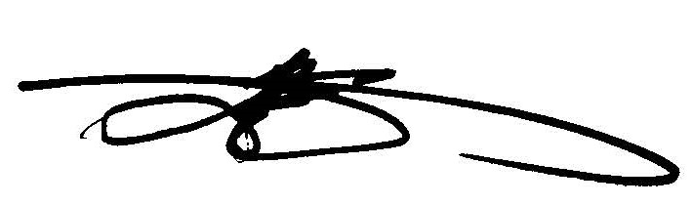
Donella Edwards, Board Secretary/SBA
Atlantic Community Charter School

