MEMO

To: Members of the Board of Trustees

From: Donella Edwards, Board Secretary/SBA

Date: February 16, 2021

Subject: NOTICE OF FEBRUARY REGULAR BOARD OF TRUSTEES MEETING

Due to the continuing health crisis, the February Regular Meeting of the Board of Trustees of Atlantic Community Charter School will be held on Thursday, February 18, 2021 at 4:00 PM, via telephonic conference only. Action will be taken at this meeting.

**The applicable information for calling in to this meeting will be provided via email by the Broder Law Group.

Respectfully submitted,
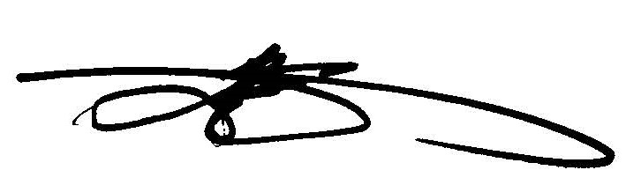
Donella Edwards, Board Secretary/SBA
Atlantic Community Charter School

