MEMO

To: Members of the Board of Trustees

From: Donella Edwards, Board Secretary/SBA

Date: January 19, 2021

Subject: NOTICE OF JANUARY REGULAR BOARD OF TRUSTEES MEETING

Due to the continuing health crisis, the January Regular Meeting of the Board of Trustees of Atlantic Community Charter School will be held on Thursday, January 21, 2021 at 4:00 PM, via telephonic conference only.

**The applicable information for calling in to this meeting will be provided via email by the Broder Law Group.

Respectfully submitted,
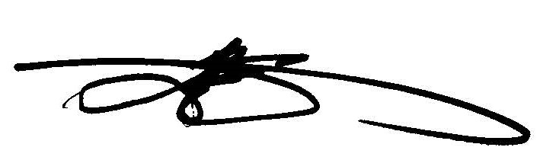
Donella Edwards, Board Secretary/SBA
Atlantic Community Charter School

