MEMO

To: Members of the Board of Trustees

From: Donella Edwards, Board Secretary/SBA

Date: November 20, 2020

Subject: NOTICE OF NOVEMBER REGULAR BOARD OF TRUSTEES MEETING

Due to the continuing health crisis, the November Regular Meeting of the Board of Trustees of Atlantic Community Charter School will be held on Tuesday, November 24, 2020 at 4:00 PM, via telephonic conference only.

**The applicable information for calling in to this meeting will be provided via email by the Broder Law Group.

Respectfully submitted,
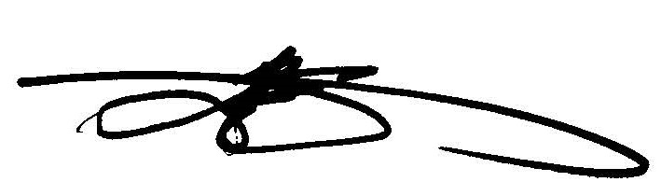
Donella Edwards, Board Secretary/SBA
Atlantic Community Charter School

