MEMO

To: Members of the Board of Trustees

From: Dr. Joseph Cappello, Board Secretary

Date: June 24, 2019

Subject: NOTICE OF JUNE REGULAR BOARD OF TRUSTEES MEETING

The June Regular Meeting of the Board of Trustees of the Atlantic Community Charter School will be held on Thursday, June 27, 2019 at 4:00 PM at the All Purpose Room of the school.

**Note: There will be no teleconferencing option available for this meeting. However, the
call-in option will remain; details will be presented in the email sent by Ilana Mindel, Broder Law Group.

Respectfully submitted,
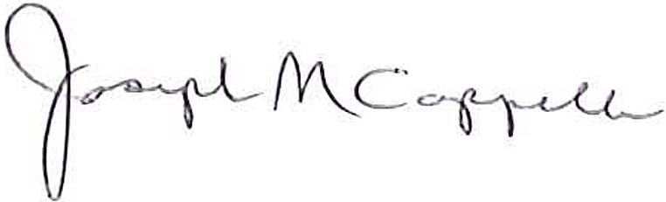
Dr. Joseph Cappello, Board Secretary
Atlantic Community Charter School

