MEMO

To: Members of the Board of Trustees

From: Donella Edwards, Board Secretary/SBA

Date: December 14, 2020

Subject: NOTICE OF DECEMBER REGULAR BOARD OF TRUSTEES MEETING

Due to the continuing health crisis, the December Regular Meeting of the Board of Trustees of Atlantic Community Charter School will be held on Thursday, December 17, 2020 at 4:00 PM, via telephonic conference only.

**The applicable information for calling in to this meeting will be provided via email by the Broder Law Group.

Respectfully submitted,
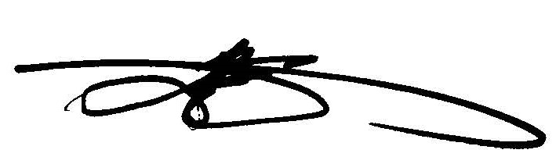
Donella Edwards, Board Secretary/SBA
Atlantic Community Charter School

