MEMO

To: Members of the Board of Trustees

From: Donella Edwards, Board Secretary/SBA

Date: June 17, 2022

Subject: NOTICE OF JUNE REGULAR BOARD OF TRUSTEES MEETING

The June Regular Meeting of the Board of Trustees of Atlantic Community Charter School will be held on Monday, June 20, 2022 at 4:00 PM, in the school’s Conference Room. Action will be taken at this meeting.

**The applicable information for calling in to this meeting will be provided via email by the Broder Law Group.

Respectfully submitted,
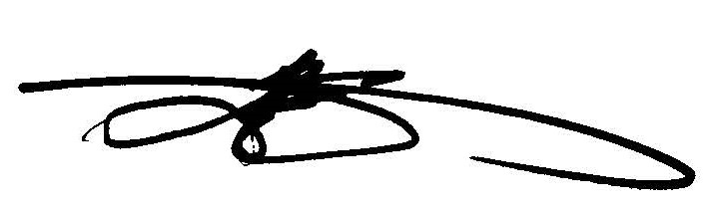
Donella Edwards, Board Secretary/SBA
Atlantic Community Charter School

